CP3 Report
Name: Cesar Mapeli

Feature Analysis

Histograms
I begin this assignment by investigating the provided feature. I started by examining the histogram of all 37 features to understand their meaning and the types of features they represented. From this analysis, I was able to understand which features were categorical (examples include features 25, 26, 12, and 15, which are normally distributed, skewed, or uniformly distributed. See the Figure 1 for the feature distributions. With this understanding, I can tailor the feature to help my model or restrain my model to predict each feature better.

Correlations
To understand how the features are correlated and whether there are any dependencies to consider when modeling. From Figure 2 ee can see a few strong positive and negative correlations. Please be mindful of the label for features at Figure 2 start at 0, not 1. I will sue the convention from Figure 1 and I will add 1 to all of the feature numbers from Figure 2, we can see features 22/37, 1/31, and 30/34 are highly positively correlate, we can also see that 22/36, and 36/37 are highly negative correlated.

Dimensionality Reduction
To gain a better understanding of the data we are working with, I used a manifold visualization to visualize our “car designs” in a 2D space. I used 2 versions of the dimensionality reduction, T-SNE and UMAP. We can see on Figure 3 that the distributions are mostly homogeneous, without any significant clustering, indicating that our designs are well distributed in the latent space.

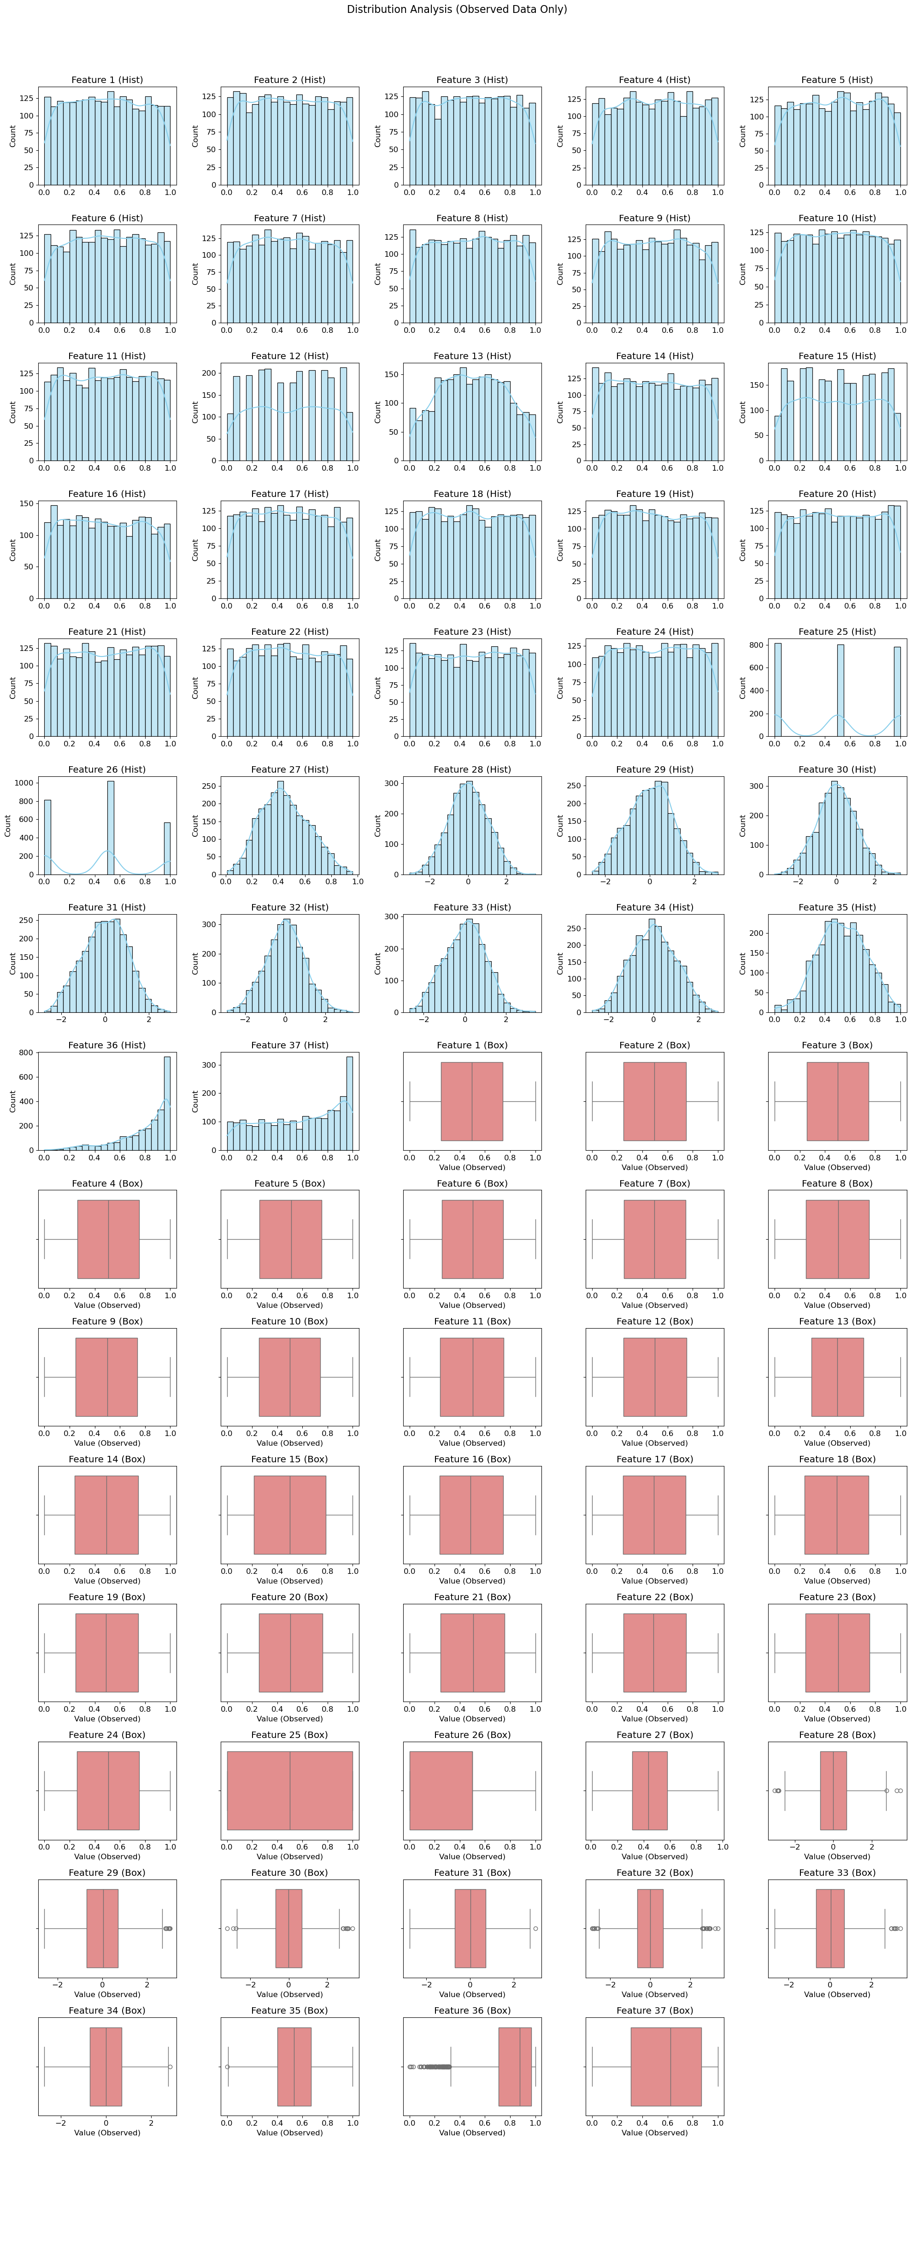
Figure 1: Features Histograms

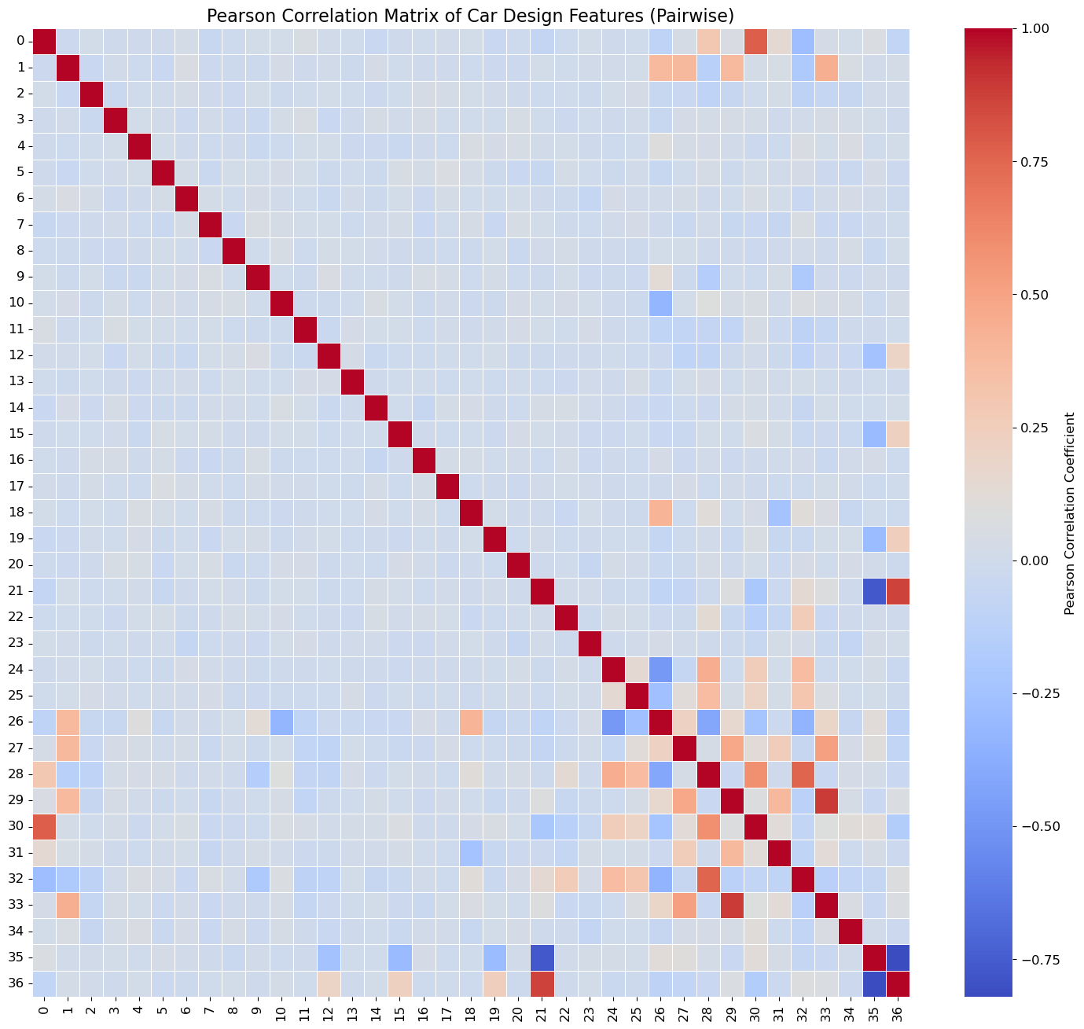
Figure 2: Pearson Correlation Matrix

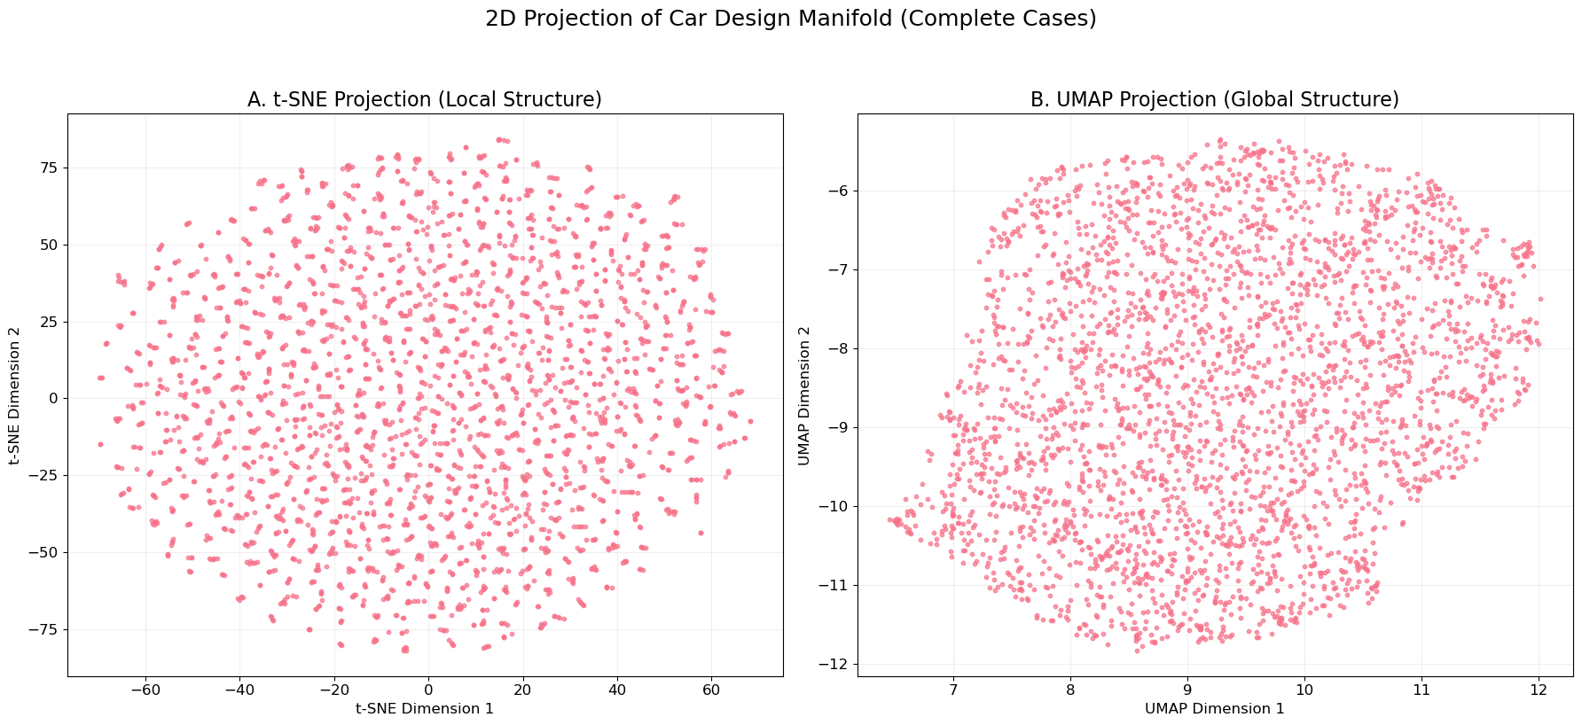
Figure 3: Dimensionality Reduction of Car Design Manifold

Modeling Approaches
I moved through three distinct phases, starting with standard Deep Learning (VAEs and Diffusion), which I struggled to get to work. I then pivoted to Gradient Boosting, which significantly improved my results.
The final phase was a Hybrid model that combined both approaches. The Gradient Boosting improved my R²/accuracy, the Diffusion injected some diversity, and the Autoencoders for validity. This approach enabled me to reach scores of nearly 0.5.

Phase 1: Deep Generative Models
My initial instinct was to use the examples provided in class and with the starter code. I tested two main architectures:

Variational Autoencoders (VAE):
I tried to teach a model to compress a car's design into a small summary code and then reconstruct it (encoding and decoding as suggested in the lecture). However, my understanding is that the VAEs work by "averaging" things out. When the model was unsure whether a value should be 0 or 1, it would play it safe and predict 0.5. This resulted in "blurry" data and did not provide good results.

Standard Diffusion (DDPM):
I trained a model to take random noise and slowly denoise it into a valid car design. However, Diffusion models assume the world is smooth (like a photograph). However, our car data had some “spiky” features. For example, some features were categorical 0, 0.5, or 1. The Diffusion model treated these as continuous numbers, producing values like 0.48 or 0.92, which were mathematically close but practically wrong for categorical decisions. I attempted in many ways to force those values into buckets, but I could not get it to work properly. I also think I was not able to properly tune this model to extract its full value.

Comments
While attempting to improve both models, my score never exceeded 0.1; all of my R² values were poor, with significant errors. My distributions for all features were behaving as Gaussian curves, and as we know, lots of the features are not Gaussian distributions.

Phase 2: Gradient Boosting
I made a priority to improve the R2 of the predicted features, and to address that problem, I attempted another method, Iterative LightGBM (Gradient Boosting). This approach immediately outperformed the Neural Networks. In my case, I believe the GB model was easier to get it to work due to its natural ability to handle mixed data types (categories and numbers) found in spreadsheets. This model came with some limitations. While the accuracy and R2 improved, the diversity was poor. To get the required 100 samples, I had to add random noise to the predictions. This noise didn't know that some features, like top speed, vary a lot, while others, like door count, vary very little.

Phase 3: Model ensemble
To break the performance ceiling, I attempted to combine models. I built a pipeline where three specialist models work in series, each fixing the mistakes of the previous one.
$$Model Ensemble=Ensemble LightGBM+Diffusion+Autoencoder$$

Stage 1: Light GBM
I start with an Ensemble of LightGBM Regressors. This model acts as the solid foundation. It ignores the noise and focuses purely on the correlations between features to obtain a good initial estimate. It creates a single, highly accurate "best guess" for every missing value.

Stage 2: Diffusion
Next, I use a Residual Diffusion Model. Instead of adding random noise, we trained a neural network to predict the errors of the first model. This model learns context-aware variety. It learns that if a car is a "Sports Car," the uncertainty in "Top Speed" should be wide, but the uncertainty in "Seating Capacity" should be very narrow. This adds the "creative spark" that makes the 100 samples look different but realistic.

Stage 3: Autoencoder
Finally, I passed the results through a Denoising Autoencoder (DAE). This acts as a "spell checker." Sometimes, Stage 1 and Stage 2 disagree (e.g., Stage 1 predicts a heavy truck, but Stage 2 adds "small engine" noise). The resulting car is "impossible." The Autoencoder recognizes this unnatural combination and snaps the data back to the nearest valid "real car" design.

Comments
As I discussed earlier, there are some features that were categorical; to predict them appropriately, I introduced a “snapping” step. It is a basic rule for all features: if a feature had fewer than 20 unique values in the training set, we forced the model's output to snap to the nearest valid category. This eliminated the "fuzzy" predictions (such as 0.48) from the continuous assumption and created categorical predictions, thereby improving the score. Note that conceptually, this is how it is supposed to work; however, I encountered some issues with certain categories, and it did not perform as well as I had expected. In Figure 4 and Figure 5 show how the features were predicted and the gaps on the predictions.

Model Scores
We started with a 0.1 score using the VAE and Diffusion models, then moved to the Light GBM with a 0.4 score. After combining all the models, I achieved a score of 0.46. After allocating additional resources, my final score improved to 0.48. The improvements in the score required some refinement, but adding time to it only marginally improved the results.
Submission Successful!
Name: Cesar Mapeli
Nickname: CM
Score: 0.4855436029557294
Submission ID: abb1494a-62da-46f1-9a96-239ddb8c5913

Feature Predictions
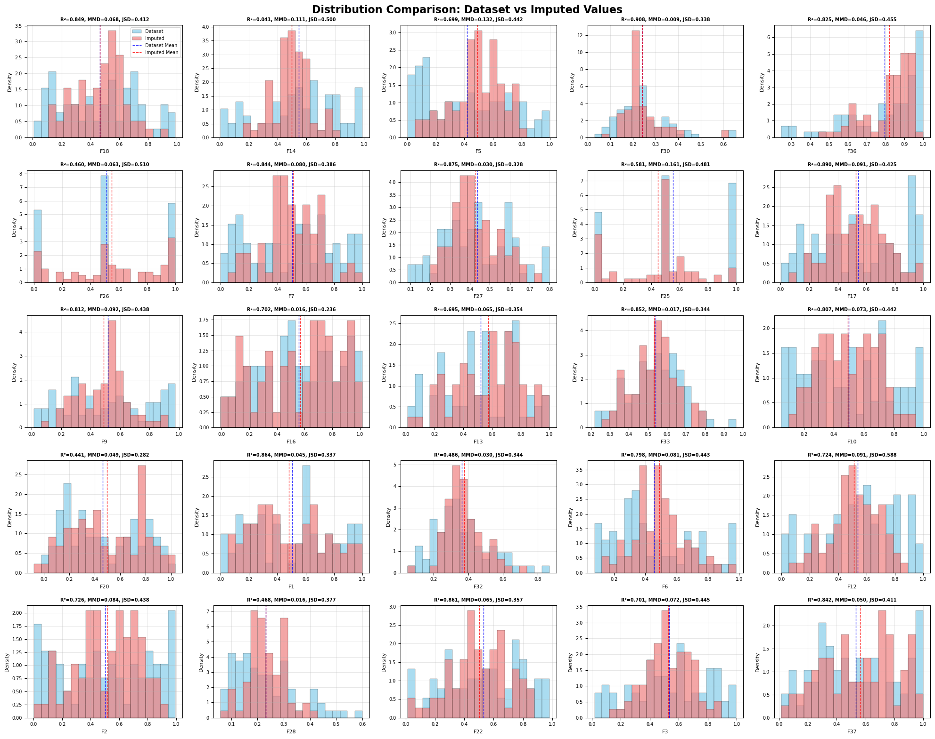
Figure 4: Feature predictions vs ground truth
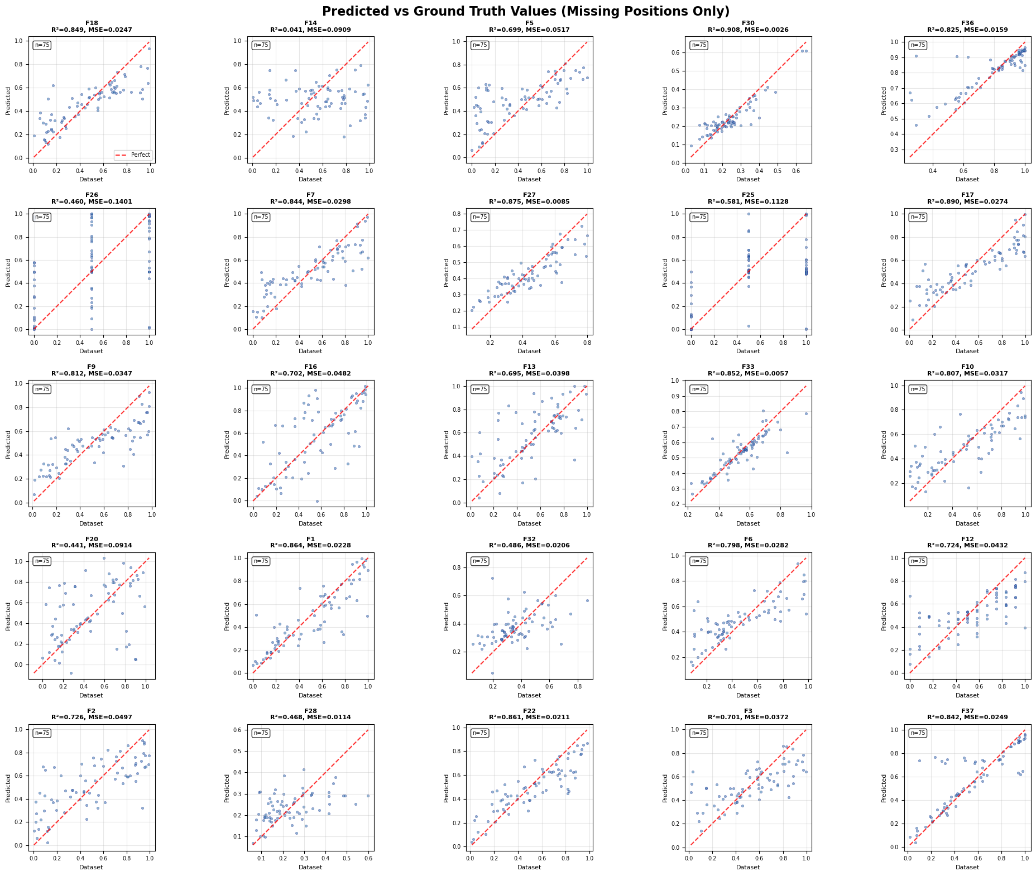
Figure 5: Accuracy of feature prediction
4. Advanced Experiments (Post-Pipeline)
After establishing the core pipeline, we attempted to push the score further with two advanced techniques:
- Explicit Feature Engineering: We added "Cluster IDs" and "Row Statistics" (mean/std of a car's features) to help the model understand the "type" of car it was looking at.
  - Result: Performance Decreased. The base features already contained this information implicitly. Adding it explicitly likely added noise or caused the model to overfit to the "average" stats rather than the specific feature values.
- Denoising Data Augmentation: We tried to train the model by artificially masking known values in the training set (teaching it to recover from even more missing data).
  - Result: Performance Decreased. The test set always has 80% missing data. Training on varying levels of missingness (e.g., 90%) confused the model about the reliability of its inputs. It learned to be "too cautious," which hurt its ability to make sharp, confident predictions.

4. Key Takeaways
- Don't force Deep Learning: For tabular data (spreadsheets), simpler Tree-based models often beat complex Neural Networks for raw accuracy.
- Model the Error, not just the Mean: The biggest improvement came when we stopped adding random noise and started learning the shape of the error using Diffusion.
- Respect the Geometry: Tabular data often has strict rules (discrete steps, impossible combinations). A generic model won't know these rules unless you enforce them via post-processing (Snapping) or refinement (Autoencoders).

AI Copilot for Car Design: Deep Tabular Imputation Report
1. Executive Summary
The goal of this assignment was to build an AI "Copilot" capable of completing car design specifications. The challenge was significant: the input data was 80% missing, and for every car, we needed to generate 100 different valid possibilities.
Our journey moved through three distinct phases of technology. We started with standard Deep Learning (VAEs and Diffusion), which struggled to handle the specific "sharpness" of spreadsheet data. We then pivoted to Gradient Boosting (Trees), which gave excellent precision but lacked creativity.
The final solution was a Hybrid Tri-Stage Pipeline that combined the best of both worlds: using Trees for accuracy, Diffusion for diversity, and Autoencoders for validity. This approach allowed us to generate cars that were both statistically accurate and structurally sound.
2. The Evolution of Approaches
Phase 1: The "Dreamer" Approach (Deep Generative Models)
Our initial instinct was to use modern Generative AI, which is famous for creating images and text. We tested two main architectures:
- Variational Autoencoders (VAE):
  - The Concept: We tried to teach a model to compress a car's design into a small summary code and then reconstruct it.
  - The Failure: VAEs work by "averaging" things out. When the model wasn't sure if a value should be 0 or 1, it would play it safe and predict 0.5. This resulted in "blurry" data that didn't look real.
- Standard Diffusion (DDPM):
  - The Concept: We trained a model to take random noise and slowly denoise it into a valid car design.
  - The Failure: Diffusion models assume the world is smooth (like a photograph). However, our car data was "spiky"—many features could only be exactly 0.0, 0.5, or 1.0. The Diffusion model treated these as continuous numbers, producing values like 0.48 or 0.92, which were mathematically close but practically wrong for categorical decisions.
Phase 2: The "Logician" Approach (Gradient Boosting)
To fix the accuracy problems, we switched to Iterative LightGBM (Gradient Boosting). Tree-based models act like giant flowcharts of "If-Then" rules (e.g., "If the engine is V8, then the weight is likely high").
- The Breakthrough: This approach immediately outperformed the Neural Networks. Trees are naturally good at handling the mixed data types (categories and numbers) found in spreadsheets.
- The Limitation: While the accuracy was high, the diversity was poor. To get the required 100 samples, we had to add random noise to the predictions. This noise was "dumb"—it didn't know that some features (like top speed) vary a lot, while others (like door count) vary very little.
3. The Final Solution: The "Assembly Line" Pipeline
To break the performance ceiling, we realized no single model could handle every part of the task. We built a pipeline where three specialist models work in series, each fixing the mistakes of the previous one.
$$\text{Final Car} = \text{Base Prediction} + \text{Learned Variance} + \text{Structural Correction}$$
Stage 1: The Sniper (Signal Prediction)
We start with an Ensemble of LightGBM Regressors. This model acts as the solid foundation. It ignores the noise and focuses purely on the correlations between features to get us 90% of the way to the truth. It creates a single, highly accurate "best guess" for every missing value.
Stage 2: The Artist (Uncertainty Modeling)
Next, we use a Residual Diffusion Model. Instead of adding random noise, we trained a neural network to predict the errors of the first model. This model learns context-aware variety. It learns that if a car is a "Sports Car," the uncertainty in "Top Speed" should be wide, but the uncertainty in "Seating Capacity" should be very narrow. This adds the "creative spark" that makes the 100 samples look different but realistic.
Stage 3: The Refiner (Manifold Projection)
Finally, we pass the results through a Denoising Autoencoder (DAE). This acts as a "spell checker." Sometimes, Stage 1 and Stage 2 disagree (e.g., Stage 1 predicts a heavy truck, but Stage 2 adds "small engine" noise). The resulting car is "impossible." The Autoencoder recognizes this unnatural combination and snaps the data back to the nearest valid "real car" configuration (heavy truck $\to$ big engine).
The Secret Weapon: "Discrete Snapping"
One of our most critical findings was that the dataset contained Hidden Categories. Several features looked like numbers but were actually categories (0.0, 0.5, 1.0). To fix this, we implemented a hard rule: if a feature had fewer than 100 unique values in the training set, we forced the model's output to snap to the nearest valid category. This eliminated the "fuzzy" predictions (like 0.48) that were hurting our score.
4. Advanced Experiments (Post-Pipeline)
After establishing the core pipeline, we attempted to push the score further with two advanced techniques:
- Explicit Feature Engineering: We added "Cluster IDs" and "Row Statistics" (mean/std of a car's features) to help the model understand the "type" of car it was looking at.
  - Result: Performance Decreased. The base features already contained this information implicitly. Adding it explicitly likely added noise or caused the model to overfit to the "average" stats rather than the specific feature values.
- Denoising Data Augmentation: We tried to train the model by artificially masking known values in the training set (teaching it to recover from even more missing data).
  - Result: Performance Decreased. The test set always has 80% missing data. Training on varying levels of missingness (e.g., 90%) confused the model about the reliability of its inputs. It learned to be "too cautious," which hurt its ability to make sharp, confident predictions.
5. Key Takeaways
- Don't force Deep Learning: For tabular data (spreadsheets), simpler Tree-based models often beat complex Neural Networks for raw accuracy.
- Model the Error, not just the Mean: The biggest improvement came when we stopped adding random noise and started learning the shape of the error using Diffusion.
- Respect the Geometry: Tabular data often has strict rules (discrete steps, impossible combinations). A generic model won't know these rules unless you enforce them via post-processing (Snapping) or refinement (Autoencoders).
- More Features $\neq$ Better Performance: Adding engineered features or synthetic training data can backfire if the base signal is already weak. Trust the raw data.

